
AMERICAN INTERNATIONAL UNIVERSITY–BANGLADESH (AIUB)
FACULTY OF SCIENCE & TECHNOLOGY
DEPARTMENT OF PHYSICS
PHYSICS LAB 5
Fall 2023-2024

LAB REPORT ON
Determination of the time constant of an RC circuit.

Supervised by,
DR. KAMRUN NAHAR MUKTA
Submitted By
S. N. | Name | ID | Contribution
1 | Farhan Chowdhury | 23-52314-2 | Experimental Data,  Discussion, Theory
2 | Nayem Siddiki | 23-52361-2 | Theory, Discussion, Reference, Calculation
3 | Fahim Al Noor | 23-51977-2 | Analysis, Discussion,  Result, Theory
4 | Amanur Rahman | 23-52039-2 | Procedure, Discussion, Reference, Theory
5 | Mubashshirul Islam | 23-52322-2 | Apparatus, Result,  Discussion

Submission: 23 July 2023

TABLE OF CONTENTS

Topic | Page no
Title Page | 1
Table of Contents | 2
- Theory | 3
- Apparatus | 5
- Procedure | 5
- Experimental Data | 6
- Calculations | 7
- Result | 7
- Discussion | 7
- Reference | 7

Theory
A resistor-capacitor circuit (RC CIrcuit) is an electrical circuit consisting of passive components like resistors and capacitors, driven by the current source or the voltage source.
The capacitor stores energy, and the resistor connected to the circuit controls the rate of charging or discharging.
The charging and discharging of the capacitor is not an instant process but takes some time. If the resistor and capacitor are connected in series, the capacitor charges gradually through the resistor until the voltage across the resistor is equal to the supply voltage.

Charging of Capacitor
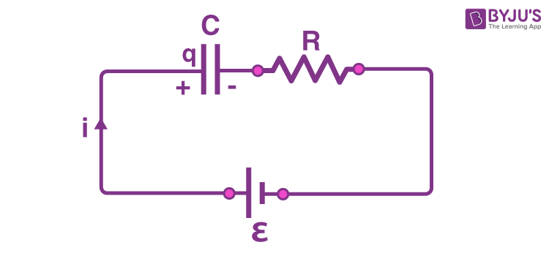
Let us consider that a fully discharged capacitor is connected to the circuit, and the switch is open. The initial condition of the circuit is time (t) = 0, charge (q) = 0 and current (i) = 0. When the switch is closed, the time will start from t = 0, and the current starts flowing through the capacitor and the resistor. An initially uncharged capacitor can be assumed to be a connecting wire just after the circuit is completed.
At time t = 0, the potential difference across the capacitor is zero and continues to be equal to zero just after the time t = 0.
The current flowing at this time is called the charging current, and it is calculated using Ohm’s law. The value of the current is,
i = i₀ = ε/R.
Here, ε is the emf of the cell.
R is the resistance of the resistor.
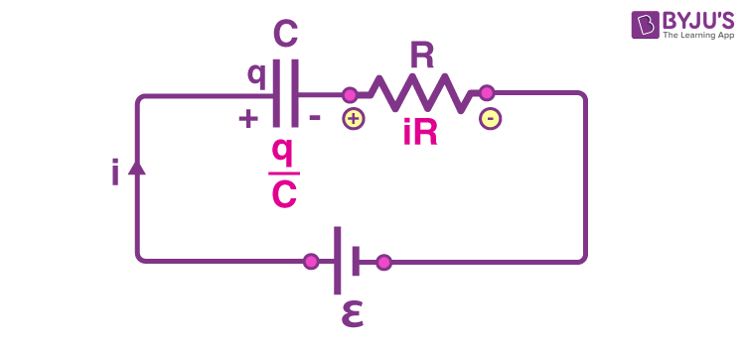
As time progresses, the capacitor charges up, and a potential difference develops across the capacitor. Let us consider at any time “t”, the charge across the capacitor is “q”, and the current in the circuit is “i”. The potential difference across the capacitor is , and the potential difference across the resistor is iR.
We find from Kirchhoff’s loop theorem:
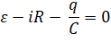
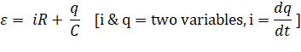
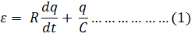
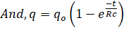
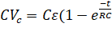 ) since, [q(t) = CV_{c}(t)] & [q₀ = Cℰ]
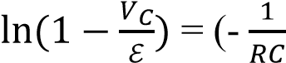)t ... ... ... ... ... ... (2)

Discharging of capacitor:
Assume now that the capacitor is fully charged to a potential V₀ equal to the emf of the battery. At a new time, t = 0, switch is thrown from A to B so that the capacitor can discharge through resistance R. Now the charge q(t) on the capacitor and the current i (t) through the discharge loop of capacitor and resistance now vary with time.
With no battery in the discharge loop, ℰ = 0, Eq. (1) becomes using Kirchhoff’s loop theorem:
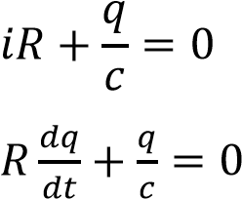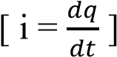
And, q = C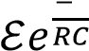
CV_{c} 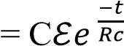 since, [q(t) = CV_{c}(t)] & [q₀ = Cℰ]
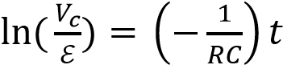 ... ... ... ... ... ... (3)

Comparing Eq. 2 and 3 with y = mx+c and plotting a graph of  for charging and 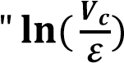 vs t” for discharging, we get the value of 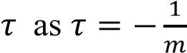, where m is the slope of the graphs.

Time Constant
The time constant (τ) = RC

Apparatus
- Power supply,
- Circuit board,
- Resistor,
- Capacitor,
- Multi meter,
- Stopwatch and
- Connecting wires.

- Procedure
- An RC circuit was constructed on the circuit board as per the circuit diagram provided.
- Upon applying a sufficient voltage from the power supply, the charging of the capacitor was observed, and the voltage differences across the capacitor were noted with time.
- Following the charging phase, the power supply was disconnected from the circuit, allowing the observation of the capacitor discharging over time. Simultaneously, the voltage differences across the capacitor were noted throughout the discharging process.

- Experimental Data:
Table 1: Charging & Discharging of an RC circuit.
Maximum potential difference (ℇ) = 6.01 volts

Time (s) | Charging capacitor |  | Discharging capacitor
Time (s) | 𝑉_{𝑐} (volt) | 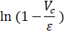 | 𝑉_{𝑐} (volt) | 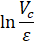
0 | 0 | 0 | 6.1 | 0.015
30 | 1.4 | -0.265 | 4.7 | -0.246
60 | 2.43 | -0.518 | 3.66 | -0.496
90 | 3.2 | -0.760 | 2.84 | -0.750
120 | 3.8 | -1.001 | 2.23 | -0.991
150 | 4.52 | -1.395 | 1.73 | -1.245
180 | 4.64 | -1.479 | 1.38 | -1.471
210 | 4.93 | -1.716 | 1.09 | -1.707
240 | 5.16 | -1.956 | 0.87 | -1.933
270 | 5.32 | -2.164 | 0.69 | -2.164
300 | 5.7 | -2.965 | 0.56 | -2.373
330 | 5.59 | -2.661 | 0.45 | -2.592
360 | 5.68 | -2.902 | 0.37 | -2.788
390 | 5.75 | -3.140 | 0.3 | -2.997
420 | 5.8 | -3.354 | 0.25 | -3.180
450 | 5.84 | -3.565 | 0.2 | -3.403
480 | 5.88 | -3.834 | 0.17 | -3.565
510 | 5.92 | -4.201 | 0.14 | -3.759
540 | 5.94 | -4.453 | 0.12 | -3.914
570 | 5.96 | -4.789 | 0.1 | -4.096
600 | 5.98 | -5.300 | 0.09 | -4.201

- Calculation:
Charging a capacitor
Theoretically:
Time constant,
Experimentally:
From the graph: Slope, m = 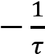
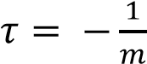 = 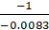 = 120.48
Error of 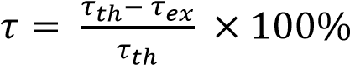 = 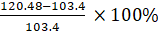 = 16.52%
Discharging a capacitor
Theoretically:
Time constant,
Experimentally:
From the graph: Slope, m = 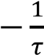
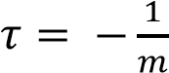 = 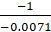 = 140.85
Error of 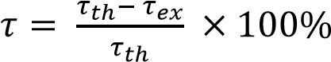 = = 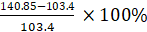 = 36.21%
Table 7.2: Values of time constant, τ.
From the graphs |  | Theoretically:  τ (=RC) | Comments
Process | Experimentally:  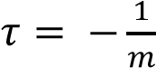 | Theoretically:  τ (=RC)
Charging
Discharging

- Resources
For further understanding students may go through the following resources:

- Fundamental of Physics (10th Edition): Capacitor (Chapter 25, page 717-721), RC circuit (Chapter 27, page 788-791).

- https://byjus.com/jee/rc-circuit/

- Video Links:
- https://www.youtube.com/watch?v=f_MZNsEqyQw
- (4) 22 - Circuits - Time constant of an RC circuit - YouTube

